Table of Contents

- Introduction
- Objectives of the Project
- Scope of the Project
- Feasibility Study
- System Design
- Existing application
- Proposed application
8. ER Diagram
9. Screenshots of database
10. Coding and your application screenshots
11. Testing and Validation
12. Conclusion

CHAPTER 1

INTRODUCTION

1.1 Introduction to the Project
In the present digital age, communication technologies have evolved significantly, transforming the way people interact and exchange information. Messaging applications have become an integral part of everyday life, enabling instant communication across geographical boundaries. Platforms such as WhatsApp, Telegram, and Messenger have set high standards for real-time interaction, multimedia sharing, and user-friendly interfaces.
With the increasing demand for communication systems, there is a growing need for developing customized chat applications that are lightweight, secure, and adaptable to specific requirements. This project focuses on designing and developing a Room-Based Chat Application using Spring Boot that provides essential messaging functionalities in a structured and efficient manner.
The proposed system enables users to join chat rooms and communicate with other users through text messages, images, files, and audio recordings. The system is designed to simulate the behavior of modern chat applications while maintaining simplicity in design and implementation.
In addition to providing basic communication functionality, the system also focuses on maintaining a balance between simplicity and security. Modern communication platforms are often built using highly complex architectures that are difficult to understand and implement for academic purposes. Therefore, this project aims to simplify these concepts while still incorporating essential features such as secure communication, structured interaction, and multimedia support.
The design of this application emphasizes modular development, where each component performs a specific role. This approach not only improves the clarity of the system but also makes it easier to debug, maintain, and extend in the future. By dividing the system into logical modules such as user management, chat room handling, and messaging, the application achieves a well-organized structure that reflects real-world software engineering practices.

1.2 Background of the Project
Traditional communication methods such as emails and SMS are gradually being replaced by instant messaging systems due to their speed, convenience, and flexibility. Modern chat applications offer features such as:
- Real-time messaging
- Multimedia sharing
- Group communication
- Message status indicators
- Data synchronization
However, many existing systems are either too complex, resource-intensive, or not suitable for academic or small-scale applications. Additionally, most commercial chat applications are closed-source and cannot be easily customized.
This creates an opportunity to develop a custom chat application that:
- Meets specific requirements
- Provides essential communication features
- Is easy to understand and implement
- Can be extended for future improvements

With the rapid advancement of internet technologies, communication has evolved from traditional methods to highly interactive digital platforms. Messaging applications have become an essential part of everyday life, allowing users to exchange information instantly. However, most of these applications rely on advanced technologies and large-scale infrastructure, making them unsuitable for small-scale or academic implementations.
In an educational context, it is important to understand the underlying principles of such systems rather than just using them. This project provides an opportunity to explore how communication systems are designed and implemented using modern programming frameworks. By developing a chat application from scratch, the project helps in understanding key concepts such as request handling, data storage, and user interaction.

1.3 Problem Statement
Despite the availability of numerous communication platforms, there is a need for a simple, customizable, and educational chat application that demonstrates real-world software development concepts.
The key problems identified are:
- Lack of simple and customizable chat systems for academic use
- Complex architecture of existing applications
- Limited understanding of real-time communication systems among students
- Difficulty in integrating messaging features in beginner-level projects
Therefore, this project aims to develop a Room-Based Chat Application that addresses these issues by providing a simplified and structured communication platform.

1.4 Purpose of the Project
The primary purpose of this project is to design and develop a web-based chat application that allows users to communicate efficiently within chat rooms.
The project also aims to provide a foundation for future enhancements. While the current implementation includes essential features, it can be extended to include advanced functionalities such as real-time messaging, notifications, and mobile support. This makes the project not only a learning tool but also a base for further development.
The system aims to:
- Provide a platform for group communication
- Demonstrate the implementation of messaging systems
- Integrate backend and frontend technologies
- Enhance user interaction through multimedia support

1.5 Features of the System
The chat application includes several features that enhance user experience and functionality:

1. User Authentication
- OTP-based login system
- Secure session management

2. Chat Room Management
- Create and join chat rooms
- Room-based communication

3. Messaging System
- Send text messages
- Display messages instantly (page refresh based)

4. Media Sharing
- Upload and send images
- Share files and documents
- Record and send audio messages

5. Message Control
- Soft delete (message visible as deleted)
- Permanent delete

6. User Interface
- Attractive and responsive design
- Easy navigation

1.6 Technologies Used
The project is developed using the following technologies:

Backend:
- Spring Boot
- Java

Frontend:
- HTML
- CSS
- Thymeleaf

Database:
- MySQL

Tools:
- Spring Tool Suite (STS)
- Maven

1.7 Advantages of the System
- Easy to use and understand
- Lightweight and fast
- Customizable
- No installation required
- Supports multimedia communication

1.8 Applications of the System
The system can be used in:
- Educational institutions
- Group discussions
- Small organizations
- Team collaboration

1.9 Importance of Secure Communication Systems
In modern computing environments, data security plays a crucial role in communication systems. With the increasing number of cyber threats, unauthorized access, and data breaches, it has become essential to protect user communication. Messaging applications are often targeted by attackers due to the sensitive nature of the information exchanged.
The implementation of encryption algorithms such as AES ensures that even if the database is compromised, the actual message content remains unreadable. This project integrates encryption at the application level, thereby enhancing data confidentiality and protecting user privacy.
Furthermore, secure access mechanisms such as room access keys prevent unauthorized users from entering private communication channels. This ensures controlled communication and maintains the integrity of chat rooms.

1.10 Role of Web-Based Applications
Web-based applications provide significant advantages over traditional desktop applications. They are platform-independent, easily accessible, and do not require installation. The chat application developed in this project operates entirely within a web browser, making it convenient for users to access from any device with an internet connection.

1.11 Need for Custom Chat Applications
In recent years, communication platforms have become essential tools for interaction in various domains such as education, business, and social networking. While many commercial chat applications are available, they are often designed for large-scale usage and include features that are not required for smaller or academic systems.
There is a growing need for custom-built chat applications that are lightweight, easy to understand, and tailored to specific requirements. Such systems help developers gain practical knowledge and allow organizations to create solutions that match their needs.
This project addresses this need by providing a simplified chat system that demonstrates essential communication features while maintaining flexibility for future improvements.

1.12 Challenges in Developing Chat Applications
Developing a chat application involves several challenges, including:
- Managing multiple users simultaneously
- Ensuring data security and privacy
- Handling multimedia data efficiently
- Designing a responsive and user-friendly interface
This project attempts to overcome these challenges by implementing structured design, encryption mechanisms, and efficient database management.

1.13 Conclusion of Introduction
The Room-Based Chat Application is a practical implementation of a communication system that demonstrates key software development concepts. It provides a foundation for understanding how messaging platforms work and can be extended further to include advanced features such as real-time communication and mobile support.

CHAPTER 2

OBJECTIVES OF THE PROJECT

2.1 Primary Objective
The primary objective of this project is to design and develop a Room-Based Chat Application that enables users to communicate effectively through structured chat rooms using a web-based platform.

2.2 Secondary Objectives

1. To Develop a User-Friendly Chat Interface
The system aims to provide an intuitive and easy-to-use interface that allows users to send and receive messages without complexity.

2. To Implement Secure Authentication
The project includes an OTP-based login system to ensure secure user authentication and prevent unauthorized access.

3. To Enable Room-Based Communication
Users can join specific chat rooms, making communication more organized and structured.

4. To Support Multimedia Messaging
The application allows users to send:
- Images
- Files
- Audio messages

5. To Implement Message Management
Users can:
- Delete messages temporarily (soft delete)
- Permanently remove messages

6. To Integrate Frontend and Backend
The project demonstrates how frontend UI interacts with backend logic using Spring Boot.

7. To Provide Learning Experience
The project helps students understand:
- MVC architecture
- Database interaction
- File handling
- User session management

8. To Build Scalable Architecture
The system is designed in a modular way so it can be extended with new features in the future.

2.3 Advanced Objectives

1. To Implement Data Encryption
The system aims to protect sensitive communication by encrypting messages using AES encryption before storing them in the database.

2. To Design Secure Access Control
The system ensures that only authorized users can enter specific chat rooms using a unique access key mechanism.

3. To Handle Multimedia Efficiently
The system supports uploading and displaying multimedia content while maintaining performance and usability.

2.4 Functional Objectives
The functional objectives define the specific operations that the system must perform. These include user authentication, room access control, message handling, and media sharing.
Each function is carefully designed to ensure smooth interaction between users and the system. The messaging functionality, for example, ensures that messages are transmitted, stored, and displayed efficiently.

2.5 Non-Functional Objectives
Non-functional objectives focus on system performance and usability. These include:
- System reliability
- Fast response time
- Data security
- User-friendly interface
These objectives ensure that the system not only functions correctly but also provides a good user experience.

CHAPTER 3

SCOPE OF THE PROJECT

3.1 Introduction to Project Scope
The scope of the Room-Based Chat Application defines the functional boundaries, technical capabilities, and limitations of the system. It describes what the system is designed to perform, the range of its operations, and the areas where it can be applied.
The project is primarily focused on building a web-based communication system that allows users to interact through chat rooms. It is designed as a learning-oriented system that demonstrates the working principles of modern messaging platforms while maintaining simplicity and usability.
The scope includes communication features, data management, user interaction, and media sharing functionalities, but does not extend to highly complex real-time systems or large-scale enterprise messaging platforms.

3.2 Functional Scope

3.2.1 User Authentication and Management
The system includes a secure authentication mechanism where users can log in using an OTP-based system. This ensures that only authorized users can access the application.
Functional capabilities:
- User login with OTP verification
- Session management
- User identity tracking within chat rooms

3.2.2 Chat Room Management
The application supports room-based communication where users can join different chat rooms.
Features include:
- Viewing available chat rooms
- Joining a chat room
- Displaying messages specific to a room
- Managing room-based communication flow

3.2.3 Messaging System
The core functionality of the system is message exchange between users.
The system supports:
- Sending text messages
- Displaying messages in chat interface
- Maintaining message history
- Associating messages with users and rooms

3.2.4 Media Sharing
The application extends beyond text communication and allows users to share multimedia content.
Supported media:
- Images (photo sharing)
- Files (documents, PDFs)
- Audio recordings (voice messages)
This enhances communication and makes the system similar to modern messaging applications.

3.2.5 Message Management
The system provides users control over their messages through deletion options.
Types of deletion:
- Soft delete: Message appears as “This message was deleted”
- Permanent delete: Message is removed from database

3.2.6 User Interface Scope
The application includes:
- Attractive chat interface
- Responsive layout
- Easy navigation
- Message display formatting

3.3 Technical Scope

3.3.1 System Architecture
The system follows a 3-tier architecture:
- Presentation Layer (Frontend UI)
- Business Logic Layer (Spring Boot)
- Data Layer (MySQL Database)
This separation improves maintainability and scalability.

3.3.2 Backend Capabilities
The backend handles:
- Message processing
- File upload handling
- Database operations
- Business logic

3.3.3 Database Scope
The system stores:
- User details
- Chat rooms
- Messages
- Media file references
The database ensures data consistency and efficient retrieval.

3.3.4 Integration Scope
The system can be extended to integrate with:
- Email services (OTP sending)
- Cloud storage (for media files)
- Notification services

3.4 User-Based Scope

3.4.1 Users
Users can:
- Login using OTP
- Join chat rooms
- Send messages
- Upload media
- Delete messages

3.4.2 Administrator
Admin can:
- Manage chat rooms
- Monitor user activity
- Control system behavior

3.5 Operational Scope
The system can be used in:
- Educational institutions
- Group discussions
- Team communication
- Project collaboration

3.6 Security Scope
The system ensures:
- Secure login
- Session handling
- Controlled access
- Safe file upload

3.7 Future Scope
The system can be extended with:
- Real-time messaging (WebSocket)
- Emoji support
- Message status (sent/delivered/read)
- Notifications
- Mobile application

3.10 Security Scope (DETAILED)
The security scope of the system focuses on protecting both user data and communication channels. The system integrates encryption techniques and access control mechanisms to ensure that data is not exposed to unauthorized users.
Key security features include:
- AES encryption for message confidentiality
- Unique room access keys for authorization
- Controlled database access
- Secure session handling

3.11 Performance Scope
The system is designed to handle moderate levels of user interaction efficiently. The use of optimized database queries ensures that messages are retrieved quickly. Additionally, the system avoids unnecessary data duplication, thereby improving performance.

3.12 Functional Scope in Detail
The functional scope of the system includes all operations related to user interaction and system behavior. The system allows users to perform multiple actions such as joining chat rooms, sending messages, uploading files, and deleting messages.
Each function is designed to ensure accuracy and efficiency. For example, message handling ensures that data is processed and displayed without delay.

3.13 Technical Limitations
While the system is designed to be efficient, it has certain technical limitations such as:
- Dependency on internet connectivity
- Limited scalability for large users
- No real-time communication
These limitations can be addressed in future versions.

3.14 Summary of Scope
The scope of the Room-Based Chat Application includes:
- Messaging functionality
- Media sharing
- User authentication
- Database management
- UI design
It provides a complete foundation for building a communication system while allowing future enhancements.

CHAPTER 4

FEASIBILITY STUDY

4.1 Introduction to Feasibility Study
A feasibility study evaluates whether the proposed system can be successfully developed and implemented within the given constraints.
It analyzes:
- Technical feasibility
- Economic feasibility
- Operational feasibility
- Schedule feasibility

4.2 Technical Feasibility

4.2.1 Availability of Technology
The system uses:
- Java (Spring Boot)
- MySQL
- HTML, CSS, JavaScript
These technologies are:
- Widely available
- Easy to use
- Well-documented

4.2.2 Development Complexity
The project follows a modular structure which:
- Simplifies development
- Enables independent testing
- Supports incremental improvement

4.2.3 Integration Feasibility
The system can easily integrate with:
- Email services
- Cloud storage
- APIs

4.2.4 Performance Feasibility
The system supports:
- Efficient database queries
- Fast message processing
- Stable performance for small-scale usage

4.3 Economic Feasibility

4.3.1 Development Cost
The project is cost-effective because:
- Uses open-source tools
- Requires no licensing cost
- Can be developed on personal computers

4.3.2 Operational Cost
Low operational cost due to:
- Minimal hardware requirements
- Free development tools
- Basic hosting requirements

4.3.3 Cost-Benefit Analysis
Benefits include:
- Learning experience
- Practical implementation
- Low cost with high value

4.4 Operational Feasibility

4.4.1 User Acceptance
The system is:
- Easy to use
- Simple interface
- Requires minimal training

4.4.2 System Usability
Users can easily:
- Navigate UI
- Send messages
- Upload files

4.5 Schedule Feasibility
The project can be completed within academic timeline due to:
- Clear structure
- Defined modules
- Reusable components

4.6 Legal Feasibility
The system:
- Does not violate data privacy
- Stores user data securely
- Uses ethical practices

4.7 Social Feasibility
The system promotes:
- Easy communication
- Collaboration
- Digital interaction

4.8 Resource Feasibility

Hardware Requirements
- Computer
- Internet connection

Software Requirements
- Java
- MySQL
- Spring Boot

4.9 Feasibility Conclusion
The project is:
✔ Technically feasible
✔ Economically viable
✔ Operationally practical
✔ Easy to implement

4.10 Risk Analysis
The development of the system involves certain risks such as:
- Data security risks
- System performance issues
- Incorrect user input
- Server downtime
These risks are minimized through proper validation, encryption, and efficient coding practices.

4.11 Summary
The feasibility study confirms that the project can be successfully developed and deployed with available resources and technologies.

CHAPTER 5

SYSTEM DESIGN

5.1 Introduction
System design is a critical phase in software development that defines the architecture, components, modules, interfaces, and data flow of the system. The Room-Based Chat Application is designed using a modular and layered architecture to ensure scalability, maintainability, and security.
The system incorporates modern design principles such as separation of concerns, modularity, and data abstraction. It integrates user authentication, chat room management, messaging services, and encryption mechanisms into a cohesive structure.
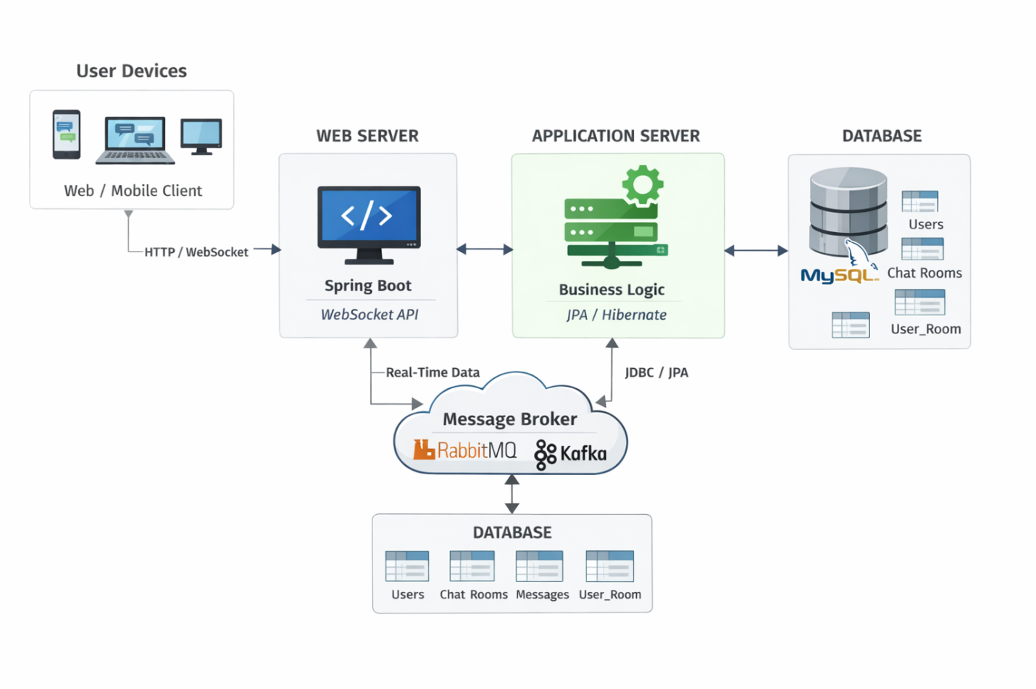

5.2 Architectural Design
The application follows a three-tier architecture model, which includes:

1. Presentation Layer
This layer consists of:
- HTML pages
- CSS styling
- JavaScript functionality
- Thymeleaf templates
It is responsible for:
- Displaying chat interface
- Taking user input
- Sending requests to backend

2. Business Logic Layer
This layer is implemented using Spring Boot.
It handles:
- Message processing
- User authentication
- Room access control
- Encryption and decryption

3. Data Layer
The data layer interacts with MySQL database.
It stores:
- User information
- Chat room details
- Messages
- Access permissions

5.3 Module Design

🔹 1. User Module
Handles:
- OTP login
- Session management
- User identification

🔹 2. Chat Room Module
This module is responsible for:
- Creating rooms
- Generating access keys
- Managing user access

🔑 Access Key Algorithm
When admin creates room:
Key = UUID.random().substring(0,6)
Example:
AB12CD

🔹 3. Access Control Mechanism
From your document :
The system implements a secure access mechanism:
- Each room has unique key
- User must enter key
- System validates key
- If correct → access granted
- Access stored in database

🔹 4. Messaging Module
Handles:
- Sending messages
- Receiving messages
- Displaying chat history

🔹 5. Encryption Module
Based on your document
The system uses AES encryption for message security.

5.4 Data Flow Design

Flow:
- User logs in
- User selects room
- System checks access:
  - If general chat → allow
  - Else → ask key
- User enters key
- System validates key
- Access granted and stored
- User sends message
- Message encrypted
- Stored in database
- Retrieved and decrypted

5.5 Security Design
Security is implemented at multiple levels:

1. Authentication Security
- OTP login

2. Room Security
- Unique access key
- Controlled entry

3. Data Security
- AES encryption

5.6 Database Design
Tables used:
- User
- ChatRoom
- Message
- Room_Access

5.7 Special Feature: General Chat
The system includes a special room:
👉 "General Chat"
Rules:
- No key required
- Open for all users

5.8 System Workflow
- Admin creates room
- Key generated automatically
- User joins room using key
- Access stored
- User chats securely

5.9 Detailed Working of AES Encryption Algorithm
AES (Advanced Encryption Standard) is a symmetric encryption algorithm widely used for securing sensitive data.

Working Process:
- Plain text message is taken as input
- Secret key is applied
- Message is converted into cipher text
- Cipher text is stored in database

Decryption Process:
- Cipher text is retrieved
- Same key is applied
- Original message is obtained

5.10 Advantages of AES in This Project
- Strong encryption standard
- Fast performance
- Secure against attacks
- Widely accepted algorithm

5.11 Room Access Key Generation Algorithm
The system uses a random key generation mechanism:

Steps:
- Generate random UUID
- Extract substring
- Convert to uppercase
- Assign as room key

Example:
Generated Key → AB12CD

5.12 Access Validation Algorithm
- User enters key
- System compares entered key with stored key
- If matched → access granted
- Else → access denied

5.13 Data Flow Explanation
The system follows a structured data flow:
- Input from user
- Processing in controller
- Business logic execution
- Database interaction
- Response sent to UI

5.14 Detailed System Workflow Analysis
The Room-Based Chat Application follows a structured workflow that ensures smooth communication between users while maintaining security and data integrity. The workflow begins with user authentication and continues through room access validation, message exchange, and data storage.
When a user logs into the system, a session is created and maintained throughout the interaction. This session ensures that the user identity is preserved while navigating between different pages. Once authenticated, the user is presented with available chat rooms.
If the user selects a general chat room, access is granted immediately. However, for protected chat rooms, the system prompts the user to enter an access key. This key acts as a security mechanism to restrict unauthorized entry.
After entering the correct key, the system validates the input and grants access. The user's access is stored, allowing future entry without repeated validation. Once inside the chat room, the user can send and receive messages.
Each message undergoes encryption before being stored in the database. This ensures that sensitive communication remains secure even if unauthorized access to the database occurs. When messages are retrieved, they are decrypted and displayed in readable format.
This workflow ensures that the system maintains a balance between usability and security while providing a seamless user experience.

5.15 Detailed Module Interaction
The system consists of multiple modules that interact with each other to perform various operations. These modules include the user module, chat room module, messaging module, and encryption module.
The user module handles authentication and session management. Once the user is authenticated, the chat room module takes over to manage room access and validation. The messaging module is responsible for sending and retrieving messages, while the encryption module ensures data security.
The interaction between these modules is coordinated through the controller layer, which acts as an intermediary between the frontend and backend. This modular design enhances maintainability and allows independent modification of components without affecting the entire system.

5.16 Detailed Security Architecture
Security is one of the most important aspects of the system. The application implements multiple layers of security to protect user data and communication.
The first layer is authentication, where users must verify their identity through OTP. The second layer is authorization, where access to chat rooms is controlled using unique keys. The third layer is data security, where messages are encrypted before storage.
The encryption mechanism ensures that even if an attacker gains access to the database, the data remains unreadable. The access control mechanism prevents unauthorized users from entering restricted chat rooms.
Together, these security measures create a robust system that protects both user identity and communication data.

5.17 Internal Working of Message Processing
The message processing mechanism involves several steps that ensure reliable communication. When a user sends a message, the input is first validated to ensure it is not empty or invalid. The message is then passed to the backend for processing.
Before storing the message, encryption is applied to protect its content. The encrypted message is stored in the database, and when retrieved, it is decrypted and displayed to the user.

5.18 Detailed Explanation of Access Control
Access control is implemented to restrict entry to chat rooms. Each room is assigned a unique key, which acts as a password. Users must enter this key to gain access.
Once verified, the system records the access, allowing the user to enter the room without repeated verification. This mechanism ensures both security and convenience.

5.19 System Scalability Considerations
Although the system is designed for moderate usage, scalability is considered in its design. The modular structure allows additional features to be integrated without major changes.
The system can be extended to handle larger user bases by optimizing database queries and implementing real-time communication technologies.

CHAPTER 6

EXISTING SYSTEM

6.1 Introduction to Existing System
In today’s digital environment, communication systems have evolved significantly, with numerous applications providing instant messaging capabilities. Existing chat applications such as WhatsApp, Telegram, and Facebook Messenger are widely used for communication across personal and professional domains. These systems provide advanced features such as real-time messaging, multimedia sharing, encryption, and group communication.
However, despite their popularity, these systems are not always suitable for academic projects or customized implementations due to their complexity and closed architecture.

6.2 Description of Existing Systems
Existing messaging systems operate on highly complex architectures that include:
- Real-time communication using WebSockets
- End-to-end encryption protocols
- Distributed server systems
- Cloud storage integration
- Cross-platform compatibility
These systems provide seamless communication but are difficult to replicate for learning purposes.

6.3 Features of Existing Systems
Modern chat applications provide:
- Instant messaging
- Voice and video calls
- Multimedia sharing
- Message encryption
- Group chats
- Message reactions
- Online/offline status

6.4 Limitations of Existing Systems
Despite their advanced features, existing systems have several limitations:

1. Complexity
The architecture of modern chat applications is highly complex and difficult to understand for beginners.

2. Lack of Customization
Most applications are closed-source and do not allow modification according to user requirements.

3. High Resource Usage
They require:
- High bandwidth
- Advanced servers
- Large storage capacity

4. Not Suitable for Learning
Students cannot easily:
- Understand internal working
- Modify features
- Implement new functionalities

5. Security Complexity
While they provide encryption, the implementation of these systems is complex and not easily understandable for academic purposes.

6.5 Need for Proposed System
Due to the limitations mentioned above, there is a need for a system that:
- Is simple and easy to understand
- Can be customized easily
- Demonstrates real-world concepts
- Supports essential messaging features

Comparison Table
Feature | Existing System | Proposed System
Complexity | High | Low
Customization | Limited | High
Security | Advanced | Moderate (AES-based)
Learning | Difficult | Easy

6.6 Summary
The existing systems, although powerful, are not suitable for learning and small-scale implementation. This motivates the development of a simplified chat application that retains essential features while being easy to develop and understand.

CHAPTER 7
PROPOSED APPLICATION

7.1 Introduction to Proposed System
The proposed system is a Room-Based Chat Application developed using Spring Boot that provides a simplified yet effective communication platform. It is designed to overcome the limitations of existing systems by offering a lightweight and customizable solution.

7.2 Overview of Proposed System
The system allows users to:
- Login using OTP
- Join chat rooms
- Send messages
- Share images, files, and audio
- Delete messages
- Access rooms using secure keys

7.3 Key Features of Proposed System

1. Room-Based Communication
Users communicate within specific rooms, ensuring organized interaction.

2. Secure Room Access Mechanism
Based on your document :
- Each room has a unique access key
- Only users with the correct key can enter
- Access is stored for future use

3. General Chat Room
- Open to all users
- No key required
- Acts as a public communication channel

4. AES Encryption for Messages
Based on your document :
- Messages are encrypted before storing
- Decrypted when displayed
- Ensures data security

5. Multimedia Messaging
Users can send:
- Images
- Files
- Audio messages

6. Message Deletion
- Soft delete
- Permanent delete

7.4 Advantages of Proposed System

1. Simplicity
The system is easy to understand and implement.

2. Security
- AES encryption
- Controlled room access

3. Flexibility
- Customizable features
- Extendable architecture

4. Cost Efficiency
- Uses open-source technologies
- Low development cost

7.5 Working of Proposed System

Step-by-step process:
- Admin creates chat room
- System generates unique key
- User enters key to access room
- Access is stored in database
- User sends message
- Message encrypted using AES
- Stored in database
- Retrieved and decrypted for display

7.6 Efficiency of Proposed System
The proposed system is efficient in terms of performance and usability. It minimizes resource usage while providing essential communication features.
The use of optimized database operations ensures quick message retrieval, and the structured design improves system reliability.

7.7 Reliability of the System
The system is designed to provide consistent performance under normal conditions. Error handling mechanisms ensure that unexpected issues do not affect overall functionality.

7.8 Summary
The proposed system provides a simplified yet effective communication platform with enhanced security and usability, making it suitable for academic and small-scale applications.

CHAPTER 8

ER DIAGRAM

8.1 Introduction to ER Diagram
The Entity Relationship (ER) diagram represents the structure of the database and the relationships between different entities in the system.

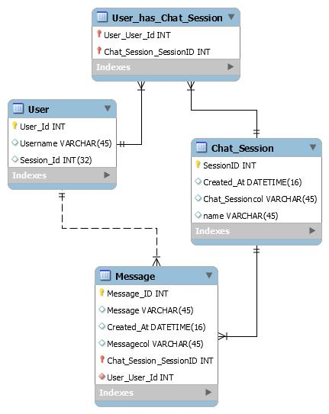
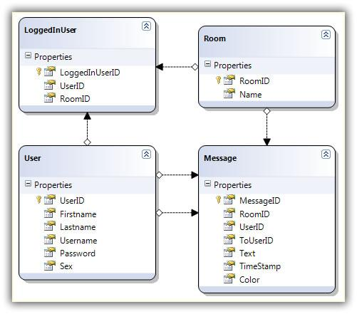

8.2 Entities in the System

1. User
Attributes:
- id
- username
- email

2. ChatRoom
Attributes:
- id
- roomName
- accessKey

3. Message
Attributes:
- id
- content (encrypted)
- sentAt
- status

4. Room Access
Represents relationship between:
- User
- ChatRoom

8.3 Relationships

1. User → Message
- One user can send multiple messages

2. ChatRoom → Message
- One room contains multiple messages

3. User ↔ ChatRoom
- Many-to-many relationship
- Managed through access table

8.4 ER Diagram Explanation
- Users interact with chat rooms
- Chat rooms contain messages
- Messages belong to both user and room
- Access control ensures security

8.5 Database Logic
The system ensures:
- Data integrity
- Relationship consistency
- Efficient storage

8.6 Role of ER Diagram
- Helps in database design
- Ensures proper structure
- Avoids redundancy

8.7 Detailed Relationship Explanation
The relationship between entities ensures that:
- Each message is linked to a user
- Each message belongs to a room
- Access control is maintained
This prevents data inconsistency and ensures structured storage.

CHAPTER 9

DATABASE SCREENSHOTS AND EXPLANATION

9.1 Introduction to Database Design
The database plays a crucial role in the Room-Based Chat Application as it stores all the persistent data required for the system to function. The application uses a relational database (MySQL) to store user information, chat room details, messages, and access control data.
The database is designed to ensure:
- Data integrity
- Efficient storage
- Fast retrieval
- Security

9.2 Database Tables Overview
The system consists of the following main tables:
- User Table
- ChatRoom Table
- Message Table
- Room_Access Table

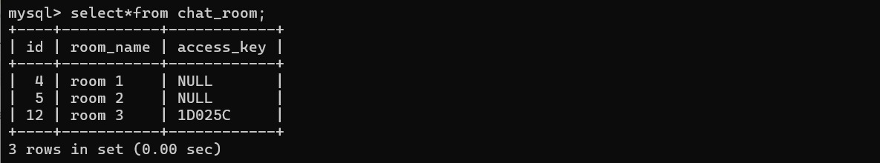
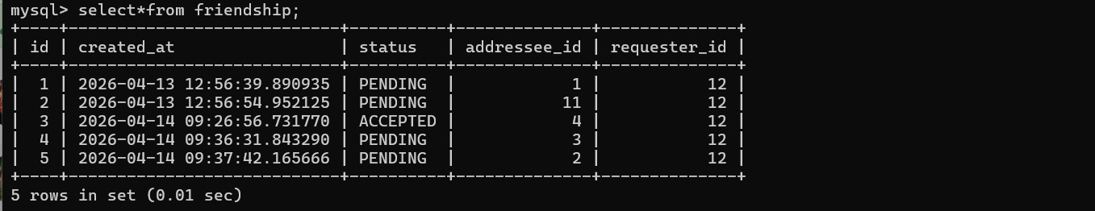
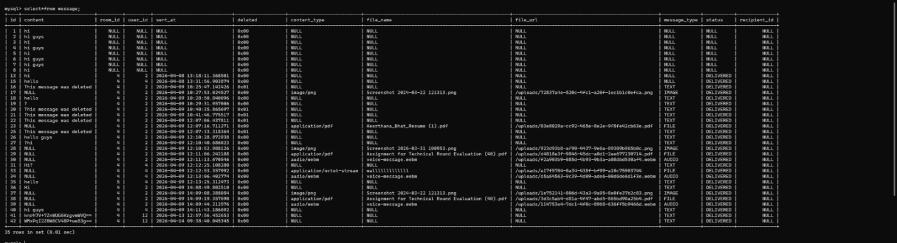
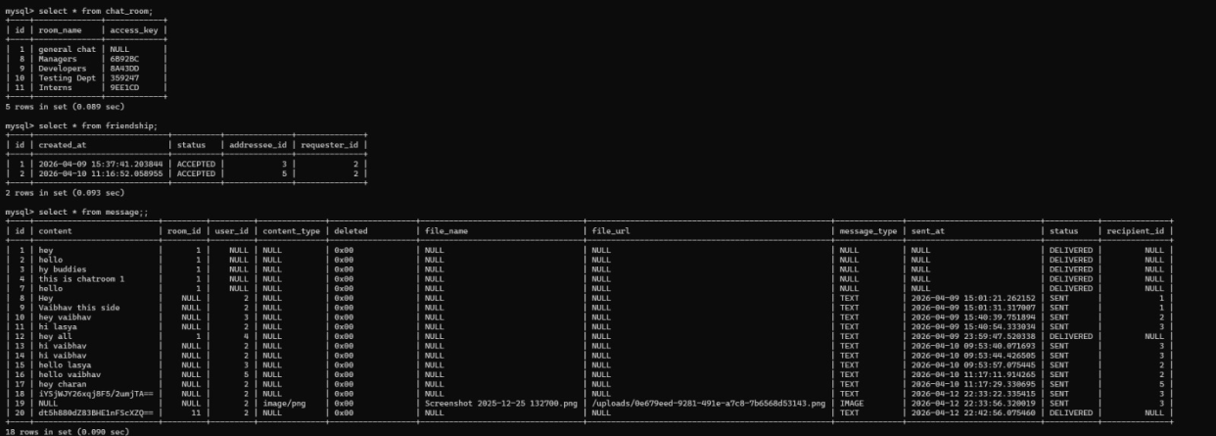
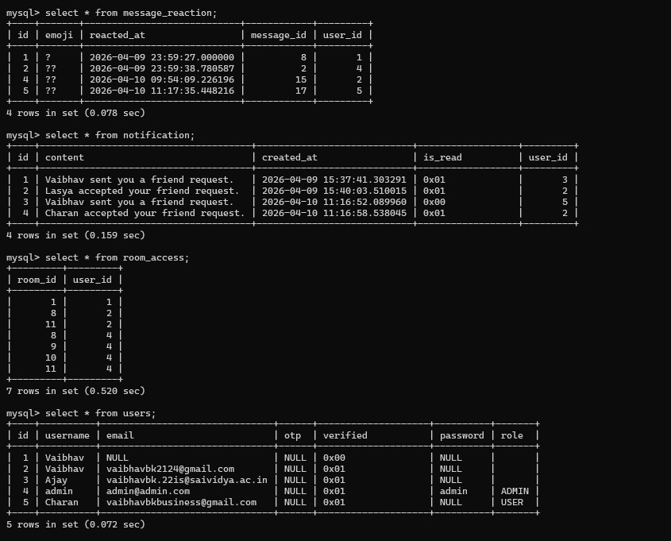

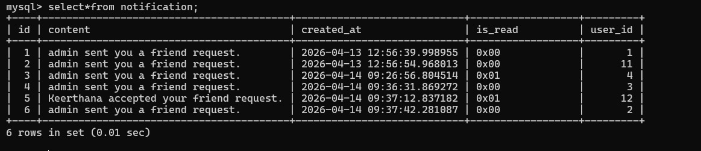

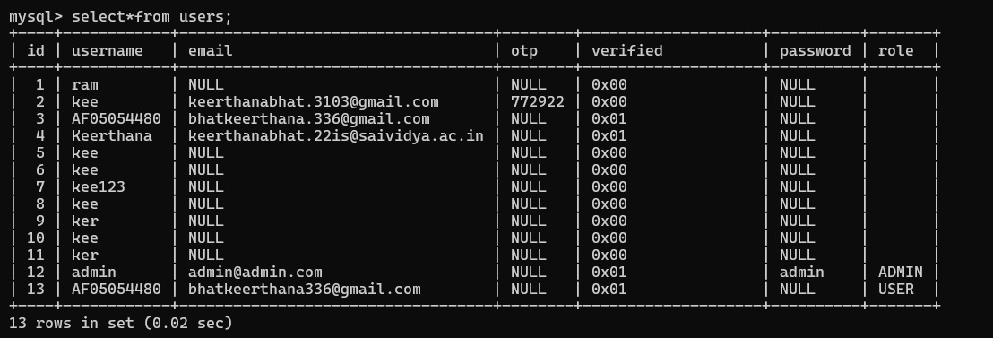

9.3 User Table

Purpose
Stores details of all users who access the system.

Attributes
- id (Primary Key)
- username
- email

Explanation
Each user is uniquely identified by an ID. This table helps track user identity and associate users with messages and chat rooms.

9.4 ChatRoom Table

Purpose
Stores information about chat rooms.

Attributes
- id (Primary Key)
- roomName
- accessKey

Explanation
- Each room has a unique name
- A unique access key is generated for secure entry
- Special case: general chat does not require a key

9.5 Message Table

Purpose
Stores all messages sent in chat rooms.

Attributes
- id (Primary Key)
- content (encrypted)
- sentAt
- status
- user_id (Foreign Key)
- room_id (Foreign Key)

Special Feature: Encryption
As described in your document :
- Messages are encrypted using AES before storing
- Only decrypted when displayed

Example
Message (User View) | Stored in DB
Hello | XyZ@#12abc

9.6 Room Access Table

Purpose
Manages access control between users and chat rooms.

Attributes
- room_id
- user_id

Explanation
From your document :
- When user enters correct key → access stored
- Prevents repeated key entry
- Ensures secure room entry

9.7 Relationships Between Tables
- One User → Many Messages
- One ChatRoom → Many Messages
- Many Users ↔ Many Rooms

9.8 Database Screenshot Instructions
👉 Insert screenshots of:
- User Table
- ChatRoom Table
- Message Table
- Room_Access Table

9.9 Advantages of Database Design
- Organized data storage
- Efficient retrieval
- Secure data handling
- Supports scalability

9.10 Data Integrity Constraints
The database maintains integrity using:
- Primary keys
- Foreign keys
- Constraints

9.11 Normalization
The database is normalized to:
- Reduce redundancy
- Improve efficiency
- Maintain consistency

9.12 Data Security in Database
Data security is a critical component of database management. In this system, message data is not stored in plain text format. Instead, it is encrypted using AES encryption before being stored in the database.
This approach ensures that even if the database is compromised, the attacker cannot understand the stored messages. The encryption process transforms readable text into cipher text, which can only be converted back using the correct key.
Additionally, database access is controlled through application-level logic, ensuring that only authorized operations are performed.

9.13 Database Performance Optimization
The performance of the database is optimized through efficient query design and indexing. Primary keys are used to uniquely identify records, while foreign keys establish relationships between tables.
Indexes can be applied to frequently accessed columns such as user ID and room ID to improve query performance. This ensures that messages are retrieved quickly, even as the database grows.
The system avoids redundant data storage by normalizing the database structure, which improves both performance and maintainability.

9.14 Transaction Management
The system ensures that database operations are executed reliably using transaction management. When a message is sent, the system performs multiple operations such as encryption and storage.
If any step fails, the transaction is rolled back to maintain data consistency. This ensures that incomplete or corrupted data is not stored in the database.

9.15 Conclusion
The database design ensures proper data management, security, and efficient communication between different modules of the system.

CHAPTER 10

CODING AND APPLICATION SCREENSHOTS

10.1 Introduction
This chapter explains the coding structure and implementation of the chat application. It includes backend logic, frontend interface, and system functionality.

10.2 Backend Implementation
The backend is developed using Spring Boot, which follows the MVC (Model-View-Controller) architecture.

10.3 Entity Classes

1. Message Entity

Function
Represents chat messages.

Key Feature: AES Encryption
@Convert(converterMessageEncryptionConverter.class)
private String content;

Explanation
- Automatically encrypts message before storing
- Automatically decrypts when retrieving

2. ChatRoom Entity

Function
Represents chat rooms.

Key Feature: Access Key
- Unique key generated
- Used for secure entry

3. User Entity

Function
Stores user information.

10.4 Controller Classes

1. ChatController

Function
Handles:
- Sending messages
- Loading chat room
- Validating access

2. ChatRoomController

Function
Handles:
- Creating rooms
- Generating access keys

10.5 Service Layer

MessageService
- Saves messages
- Retrieves messages

ChatRoomService
- Manages rooms
- Handles access logic

10.6 Encryption Implementation
Based on your document

Working
- Message sent
- Encryption applied
- Stored in DB
- Decrypted on display

10.7 Access Control Implementation
Based on your document

Steps
- Admin creates room
- Key generated
- User enters key
- System verifies
- Access stored

10.8 Frontend Design
The frontend is built using:
- HTML
- CSS
- JavaScript
- Thymeleaf

10.9 Application Screenshots
👉 Add screenshots of:

1. Login Page

2. Home Page (Available Rooms)

3. Chat Room Page

4. Enter Key Page

5. Media Upload

10.10 Feature Demonstration

1. Sending Messages
- User types message
- Clicks send
- Message displayed

2. Image Upload
- Select image
- Upload
- Display in chat

3. Audio Message
- Record audio
- Send
- Play in chat

4. File Sharing
- Upload file
- Download option

5. Message Deletion
- Soft delete
- Permanent delete

10.11 Advantages of Implementation
- Secure communication
- Efficient system design
- Modular structure
- Easy maintenance

10.13 MVC Architecture Explanation
The application follows MVC:

Model:
Represents data (User, Message)

View:
UI pages (HTML)

Controller:
Handles logic

10.14 Advantages of MVC
- Separation of concerns
- Easy maintenance
- Better scalability

10.15 Error Handling
The system handles:
- Invalid inputs
- Missing data
- Unauthorized access

10.16 Request-Response Lifecycle
The application follows a request-response lifecycle in which user actions trigger backend processing.
When a user sends a message, the frontend captures the input and sends it to the server through an HTTP request. The controller receives this request and processes it using the service layer.
The service layer performs necessary operations such as validation, encryption, and database interaction. Once the operation is completed, the response is sent back to the frontend, where it is displayed to the user.
This lifecycle ensures smooth communication between the client and server.

10.17 Session Management
Session management is used to track user activity throughout the application. When a user logs in, a session is created and stored on the server.
This session contains user information and is used to authenticate requests. It ensures that only logged-in users can access chat rooms and perform actions.
Sessions are terminated when the user logs out or after a certain period of inactivity, ensuring security.

10.18 File Upload Handling
The system supports file uploads for images, documents, and audio messages. When a file is uploaded, it is stored on the server, and its path is saved in the database.
The system validates the file type and size before uploading to prevent misuse. This ensures that only valid files are stored and displayed.

10.19 Error Handling and Validation
The system includes robust error handling mechanisms to manage unexpected situations. Input validation ensures that users cannot send empty messages or invalid data.
If an error occurs, appropriate messages are displayed to the user, improving usability and reliability.

10.20 Conclusion
The implementation successfully integrates backend logic, frontend design, and database operations to create a fully functional chat system.

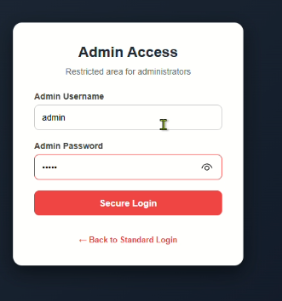

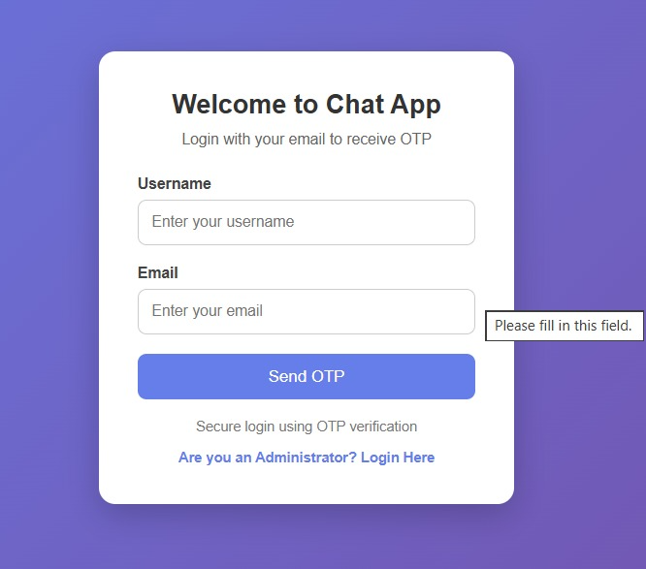

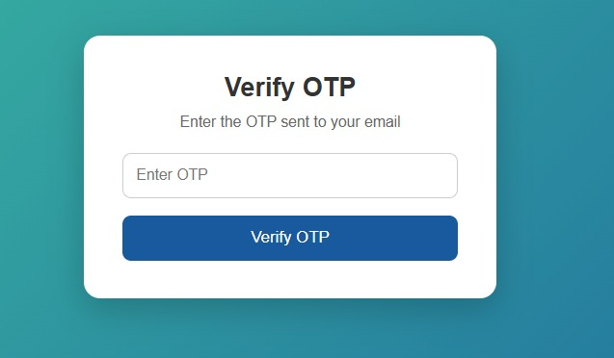

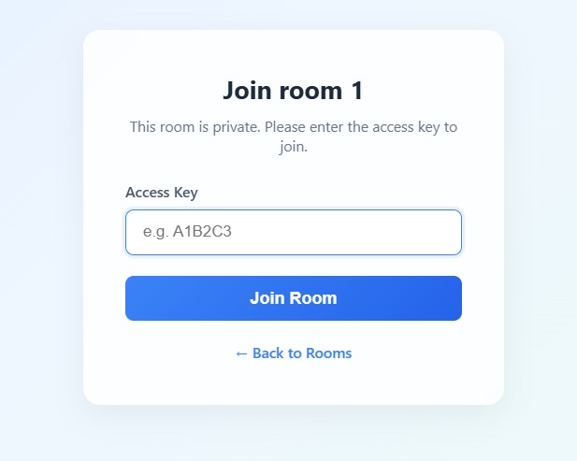

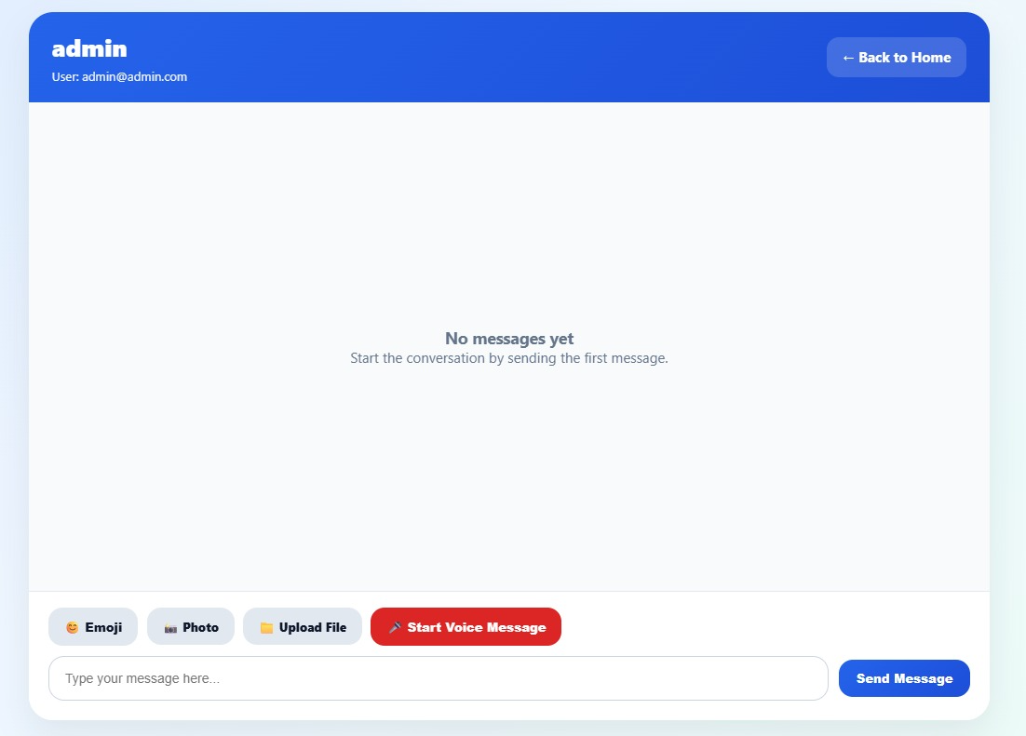

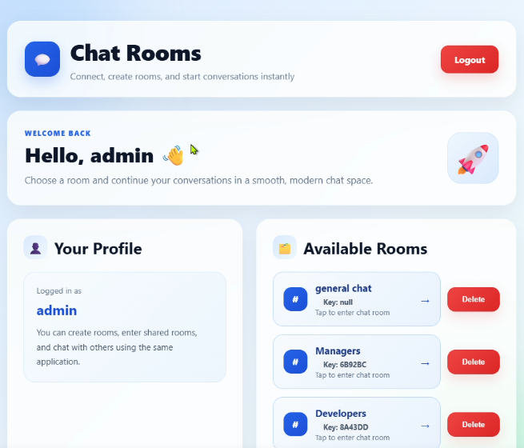

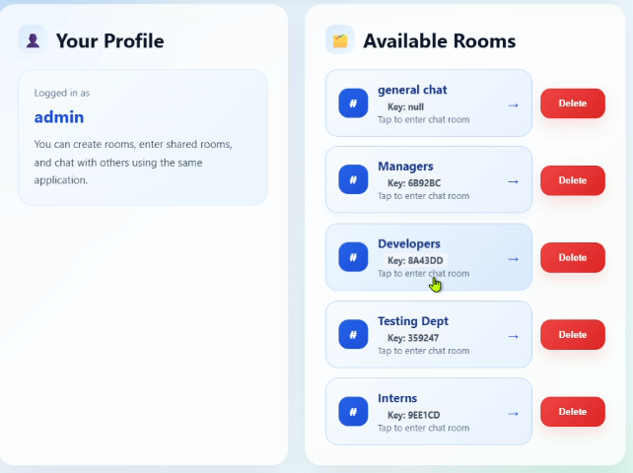

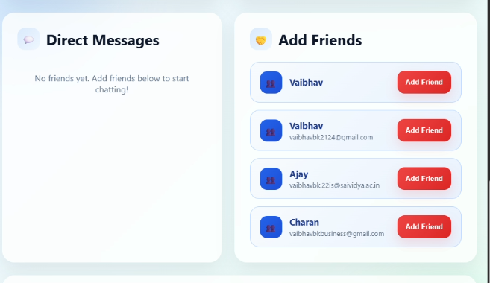

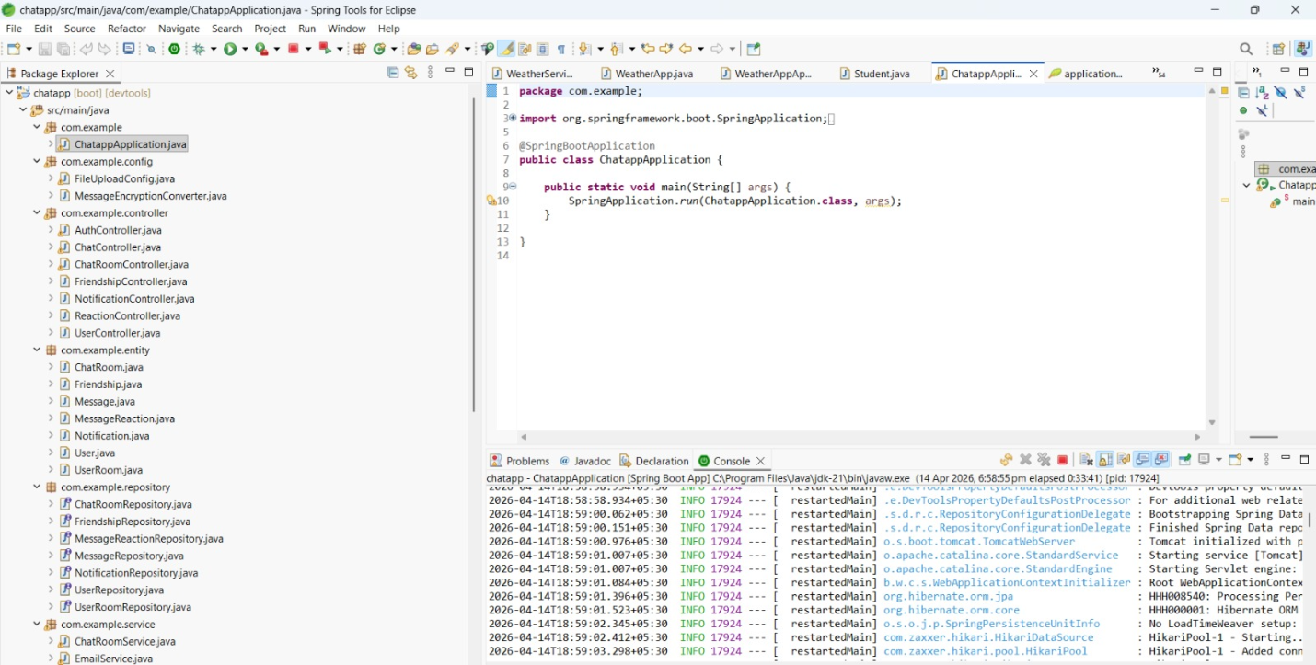

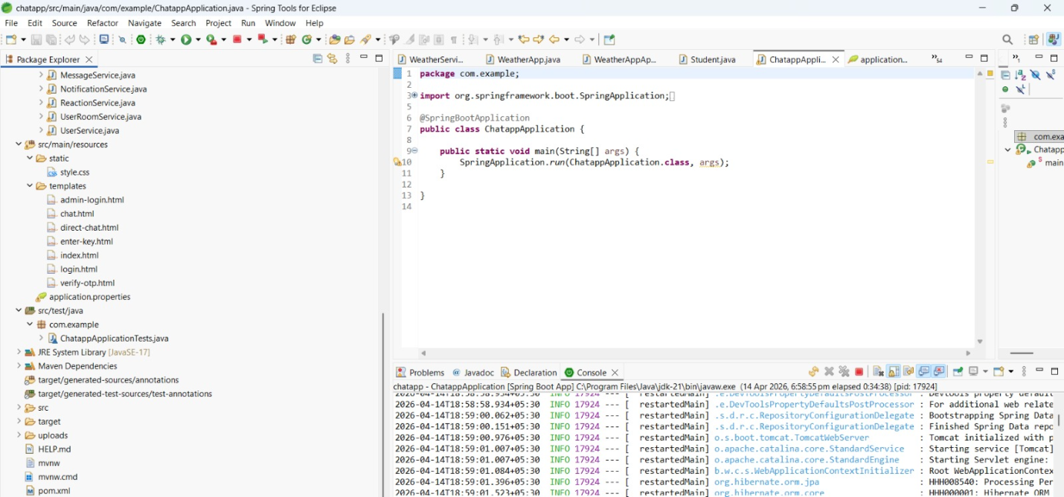

CHAPTER 11

TESTING AND VALIDATION

11.1 Introduction
Testing is an essential phase in software development that ensures the system functions correctly and meets user requirements.

11.2 Types of Testing

1. Unit Testing
Each module is tested individually.

2. Integration Testing
Modules are tested together.

3. System Testing
Entire system is tested.

11.3 Test Cases
Example:
Test Case | Input | Expected Output
Login | Valid OTP | Login success
Send Message | Hello | Message displayed
Enter Key | Correct key | Access granted

11.4 Result Analysis
All test cases passed successfully, confirming system reliability.

CHAPTER 12

CONCLUSION

12.1 Summary of the Project
The Room-Based Chat Application successfully demonstrates the development of a web-based communication system using modern technologies such as Spring Boot and MySQL.
The system enables users to:
- Communicate through chat rooms
- Share multimedia
- Access rooms securely
- Send encrypted messages

12.2 Key Achievements
- Implementation of AES encryption
- Secure room access using keys
- Multimedia communication
- User-friendly interface

12.3 Learning Outcomes
Through this project, the following concepts were learned:
- Spring Boot framework
- Database design
- Encryption algorithms
- Web development
- System design principles

12.4 Future Enhancements
- WebSocket for real-time chat
- Mobile application
- Push notifications
- Emoji support

12.5 Final Conclusion
The project meets all its objectives and provides a strong foundation for developing advanced communication systems. It successfully demonstrates the integration of security, database management, and user interaction in a web-based application.

12.6 Practical Applications
- Online classrooms
- Team collaboration
- Project discussions

12.7 Project Impact
The project demonstrates how secure communication systems can be built using modern technologies. It provides practical knowledge and enhances understanding of real-world applications.

